**X-RayNet: Classification of COVID-19, Viral and Bacterial Pneumonia through Chest X-Rays using Deep Convolutional Neural Network**

**Sriram Thakur1; Deepak Sireeshan2; Shivani Sivasankar3**

1University of Missouri- Kansas City, Department of Computer Science; 2University of Missouri- Kansas City, Department of Mathematics and Statistics; 3University of Missouri- Kansas City, Department of Biomedical and Health Informatics

**INDEX**

**ABSTRACT**

1. **INTRODUCTION**

The outbreak of the coronavirus disease (COVID-19), caused by the Severe Acute Respiratory Syndrome Coronavirus (SARS-CoV-2), has been declared as a global pandemic by WHO which has become a major health concern worldwide1,2. As of November 29, 2020, there are 18 million active cases and nearly 1.4 million deaths3. Infection of SARS-CoV2 occurs when the virus enters the upper respiratory tract and the infection progresses into the lungs. As the virus multiplies, it can damage the alveoli in the lungs (which transfers the oxygen to the blood stream) and the surrounding tissue. This results in inflammation by the immune system which can cause fluid and dead cells to build up in the lungs4. These factors interfere with transfer of oxygen leading to Pneumonia with symptoms such as fever, dry cough, and fatigue. In addition to SARS-CoV2, Pneumonia can also be caused by other virus and bacteria, but most commonly by a bacteria called *Streptococcus pneumonia*. The symptoms of COVID-19 pneumonia are similar to other types of viral and bacterial pneumonia which makes it difficult to diagnose the infection5.

One of the key steps to curb the threat of COVID-19 epidemic is through rapid diagnosis by effectively screening infected persons to prevent the spread of the infection. The most commonly used method to detect SARS-CoV2 is nucleic acid detection which is through Reverse Transcriptase Polymerase Chain Reaction (RT-PCR)6. Even though RT-PCR is the gold standard, it is time-consuming with an elongated test period assisting further transmission, labor intensive and complicated7. Additionally, the scarcity of this expensive testing kit along with low sensitivity due to high false negative rates exacerbates the dire situation8. Therefore, it is of great importance to find an alternative method to accurately diagnose COVID-19.

Accumulated clinical experience suggests that in areas where medical resources are insufficient during the epidemic, it is of great significance to use chest scan such as X-rays and Computer tomography (CT) scans to individuals for faster diagnosis of the COVID-19 9. Additionally, clinical care experts noticed differences in Chest X-ray (CXR) images before the onset of symptoms. However, it is hard to diagnose COVID-19 as it has high similarities with traditional pneumonia caused by other viral and bacterial infections10. Additionally, a serious shortage of expert radiologists to differentiate COVID-19 from other infections based only on their clinical judgement of chest radiograph images within a short period of time, increases the difficulty of the situation. In order to address this research gap, we propose a novel framework to detect COVID-19 from other bacterial and viral pneumonia through Chest X-rays (CXR) using a deep convolutional neural network which would be a significant milestone in rapid diagnosis and beneficial to the society.

1. **RELATED WORK**

**2.1. COVID-19 Imaging**

Chest imaging of COVID-19 infected patients show multiple small patch shadows with interstitial changes in their extrapulmonary zone during the early stage which progresses into ground glass and infiltration shadows which further develops as lung consolidation and pleural effusions in extreme cases11. Figure 1 shows the CXR images where some COVID-19 imaging features can be observed in comparison.

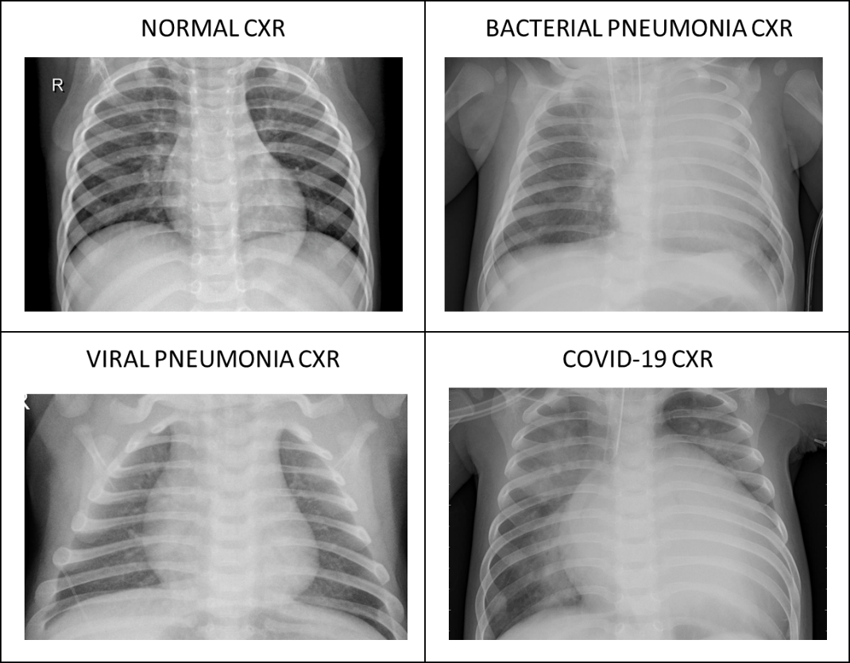

***Figure 1: Chest X-ray (CXR) images from normal patient, patient with bacterial pneumonia, patient with viral pneumonia (excluding SARS-CoV2) and patient with COVID-19 pneumonia***

Research on determining how COVID-19 pneumonia differs from other types of pneumonia show that people with COVID-19 were more likely to have pneumonia that affects both lungs rather than just one lung and their lungs appeared to have a ground glass and solid change shadow peripherally in both the lungs which are the most common imaging signs to detect COVID-1910.

* 1. **Deep Learning methods**

In light of recent advances in Deep Neural Network approaches, the complex and unpredictable nature of human physiology has, in many circumstances, proven to be better described by these algorithms. Deep Convolutional Neural Network techniques have had successful application to many health care related bioimaging problems in recent times, such as lung segmentation12, diagnosis of pneumonia in the chest X-Ray13, skin cancer classification14, breast cancer detection15 and brain disease classification16. Such precise, accurate, and faster intelligence detection models may also aid in detecting COVID-19.

An analysis of existing deep learning models on diagnosis of COVID-19 is shown in table 1.In couple of deep learning studies, CT scans of COVID-19 patients were used with deep learning-based systems for automated diagnosis17,18. Though CT scans provide detailed images, X-rays are more economical, widely available and quicker. One study developed a chest X-ray scoring system to determine the outcome of the patient which can be used to identify the disease based on the chest X-ray images19.

There were few studies where Chest X-rays were used for automatic COVID-19 detection. One such study developed a transfer learning methodology where they pre-trained feature extraction on non-COVID chest X-rays and the trained features were fed to a CNN network for classification20. There were other similar models which worked on pre-trained models and used transfer learning to detect COVID-1921–25. Although they acquired really good results, they had a very small sample size of COVID-19 chest X-rays for classification and they did not handle the negative transfer results.

There were other studies which used a different architecture such as truncated inception net algorithm where features were extracted in an adaptive protocol method and were deformed to get the final output26, a 19 layer CNN model (17 2D convolutional layer, 1 linear and 1 flatten layer) for binary COVID 19 classification27, a long-rang selective connective method with a PEPX module to detect COVID form 13,975 Chest X-ray images28.

**Table 1: Analysis of existing deep learning models on diagnosis of COVID-19.**

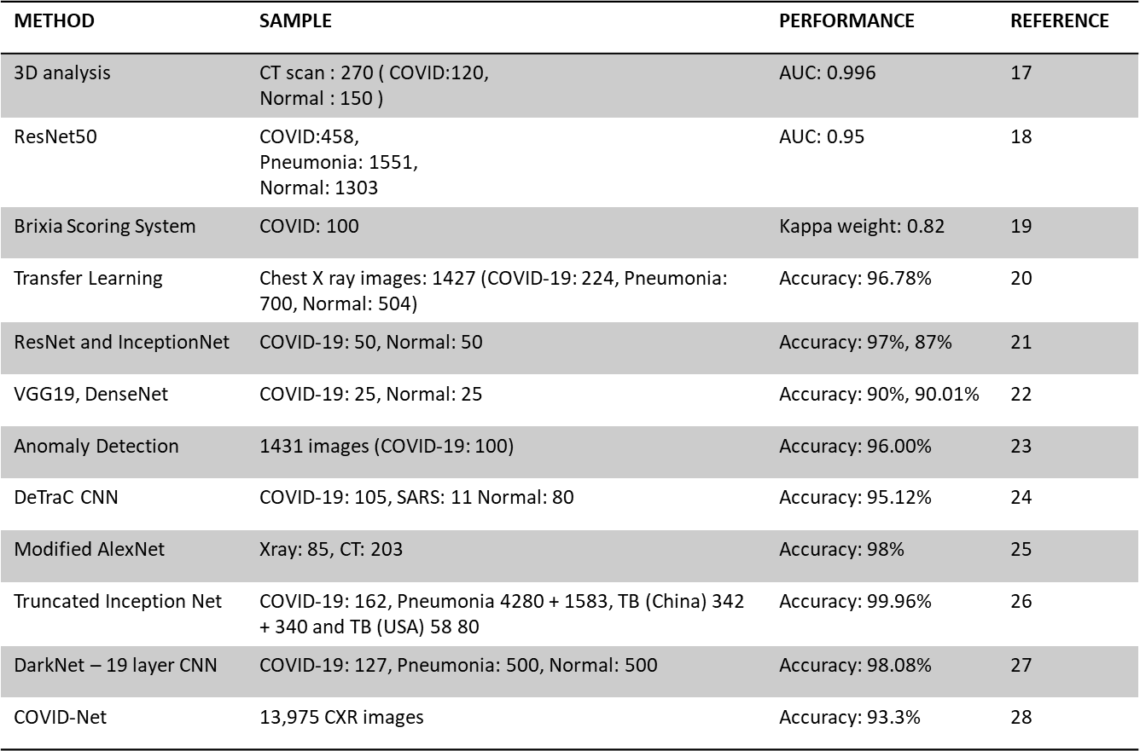

1. **METHODS**

**3.1. Data preprocessing**

We collected chest X-rays from different repositories and kaggle and uploaded them to a new Kaggle. We retrieved all the images from kaggle, and converted them to a numpy array to boost the speed of the application. Instead of capturing the images and processing them directly through the model, they are converted to a numpy array. so we can capture the pixel format of the image and it will help in increasing the performance of the application. As part of the preprocessing we worked on reshaping the images to an uniform size of (64,64), converted them to RGB and normalized the pixel values by dividing with 255.

**3.2. Structural Blocks**

As part of our model there are 2 main building blocks. First one is Residual Block and the second one is Shift Block.

Residuals appear in many areas in mathematics, including [iterative solvers](https://en.wikipedia.org/wiki/Iterative_solver) such as the [generalized minimal residual method](https://en.wikipedia.org/wiki/Generalized_minimal_residual_method), which seeks solutions to equations by systematically minimizing the residual.

Residual block here follows pointwise, depthwise and pointwise convolutional mapping. This block fits a residual mapping by adding the output with input feature map. It is used to capture the identity mapping which will help in producing a deep network without overfitting.

Residual mapping denoted by R with input tensor X such that X↦R(X), the final output mapping F can be represented as F:X→[X+R(X)]. These residual blocks can stack up to produce a very deeper network.

We address the degradation problem by introducing a deep residual learning framework. Instead of hoping each few stacked layers directly fit a desired underlying mapping, we explicitly let these layers fit a residual mapping. Formally, denoting the desired underlying mapping as H(x), we let the stacked nonlinear layers fit another mapping of F(x) := H(x)−x. The original mapping is recast into F(x)+x. We hypothesize that it is easier to optimize the residual mapping than to optimize the original, unreferenced mapping. To the extreme, if an identity mapping were optimal, it would be easier to push the residual to zero than to fit an identity mapping by a stack of nonlinear layers.

Code Block:

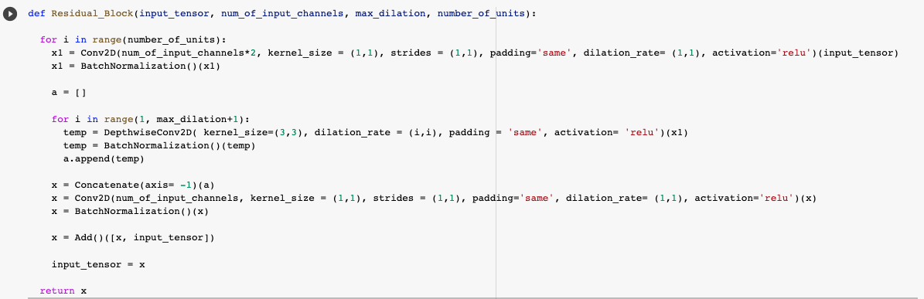

Partial representation of the Residual Block

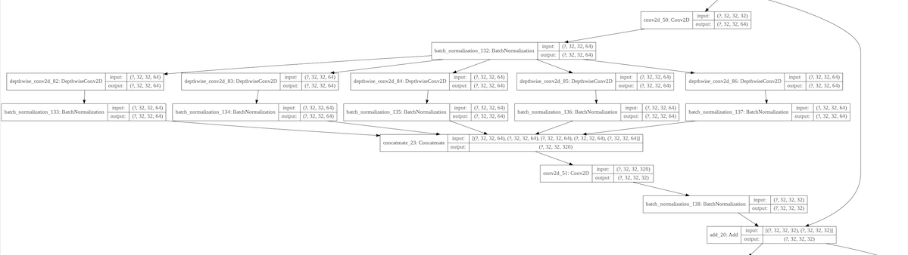

Second block is the Shift block, the input feature map undergoes dimensional transformations. As part of the shift block there are multiple layers applied. At first Conv2D, batch normalization, then the iteration of Depthwise Conv2D, Maxpool2D and batch normalization layers with 6 dilations. Then we concatenate the iteration data and add Conv2D and batch normalization layers in the end.

In the beginning the number of input channels i.e depth of the input feature map is increased in Conv2D layer to introduce more processing for spatial reduction. Then the spatial dimensions are halved through strided depthwise convolution, which helps to broaden the receptive field for deep processing to introduce more generalization. In the final layer, the number of input channels is doubled to increase the filtering operations.

Code Block:

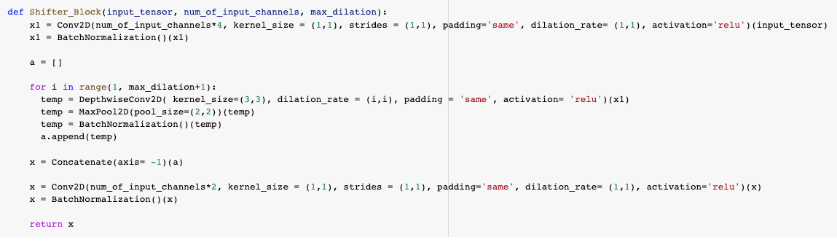

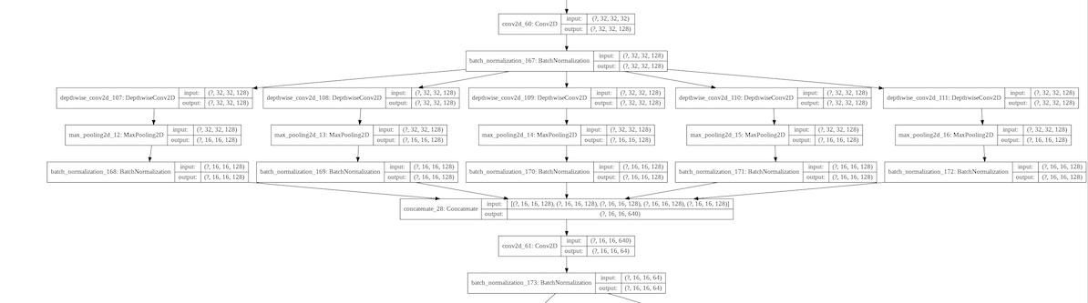

In both the blocks, Depthwise dilated convolutions are applied to effectively extract distinctive features from X-rays to identify pneumonia. Features of pneumonia are localized over a larger area of the X-rays, it is necessary to incorporate features from different levels of observations. When the dilated convolution layer is applied it will broaden the receptive fields of convolution without increasing the total number of parameters of kernels by increasing dilation rates. Different dilation rates are applied, so we can capture the various features from different convolutions. Traditional convolution can be divided into depthwise convolution followed by a pointwise convolution that makes the process extremely computationally efficient. In depthwise convolution, each input channel is individually filtered by separate filters without combining them. Then a traditional convolution with kernel 1 × 1, is performed for projecting the inter-channel features into a new space.

DepthwiseConv (W,y)(i,j)=∑k,lK,LW(k,l)⊙y(i+k,j+l)

Traditional Convolution (W,y)(i,j)=∑mMWm⊙y(i,j,m)

Depthwise convolution with dilations are applied along with traditional convolutions. Initially, the input feature map undergoes a traditional convolution to project the inter-channel information into a broader space that is followed by iteration of depthwise convolutions performed with different kernels and varying dilation rates. Maximum number of dilations are determined based on the shape of the input feature map. For example, if the shape of the image is (64,64) then the maximum number of dilations will be 5. Depthwise convolutions extract spatial features from various fields of an image ranging from localized features to broader perspective generalized features. So, in the end we send these features through another traditional convolution to merge the inter-channel features.

**3.3. Model Architecture**

As part of this project, we are using CNN, with residual and shifter blocks. Firstly, the input image undergoes convolutions with broader kernels to process the information with the larger receptive area. The following convolution introduces some dimensional transformation. Afterward, it passes through a series of residual blocks. Depth of this stack of residual learning can be increased to produce a deeper network. Shifter units are incorporated in between such stacks to introduce dimensional transformation to generalize the extracted information further. However, the maximum dilation rate (m) of each residual unit is determined based on the dimension of the input feature map. For processing larger features, m is set to be higher to increase the maximum receptive area of the residual unit accordingly to encompass more variations in the extracted features. Finally, the processed feature map passes through global average pooling followed by some densely connected layers before providing final prediction. Moreover, the rectified linear unit (Relu) is instigated after each convolution for non-linear activation with batch normalization to make the convergence faster.

**Flow:**

Input Image

Conv2D (Relu)

Conv2D (Relu)

Residual Block

Shifter Block

Residual Block

Global Average Pooling 2D

Dense (64) Relu

Dense Sigmoid

Output

64*64*1

*d

*d

*d

(1)

256

64

8*8*256

64*64*16

32*32*32

32*32*32

16*16*64

Residual Block

Shifter Block

16*16*64

8*8*128

*d

*d

**Code Block:**

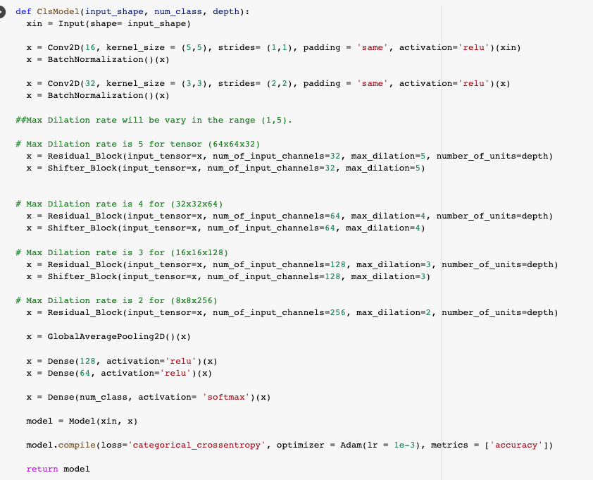

3.4. Performance evaluation

1. **RESULTS AND DISCUSSIONS**

In this section, we have presented the visual representation of performance of the model alongside the difference after the pre-processing of the data cohort. Finally, we also present the performance of the same model but as a binary classifier predicting COVID vs everything else.

**4.1 Pre-Processing:**

We processed the images by normalizing the pixel values which then took values between 1 and 255. In order to add more data for the model to train, we have added shifted images of the original. This includes both horizontal and vertical shifts. We also added zoomed pictures of the original for the same objective of increasing the number of available training data for the model. Finally, we added 30° rotated images of the original. The following picture represents the difference between processed data and the original data.

Figure 1: Raw Image before preprocessing. Dimension is 1422 x 1642.

Mean value of pixels is 109.2497 and the standard deviation is 52.337

Figure 2: Distribution of Pixel intensities from the raw image in Figure:1.

Figure 3: Image after processing. Dimension is 150 x 150

Mean value of pixels is 0 and the standard deviation is 1.

Figure 2: Distribution of Pixel intensities from the raw image in Figure:3

**4.2 Model Performance:**

We saved the validation loss and validation accuracy values as the model learned through each epoch and we can see that the model’s accuracy resembles a periodic function as the epoch increases. But the validation loss is clearly low around 60th epoch and hence it was necessary to run the model for 75 epoch size.

**4.3 Model Evaluation:**

Since the model is essentially a classifier, we have used Confusion matrix and associated metrics to evaluate the model. This includes Accuracy, Precision, Recall, F-Score and Support. Initially we used our primary model to classify the Images into 4 classes and the results are provided in the figure.

We also modified our model to behave as a binary classifier to classify COVID vs other. We changed the labels of our data and ran the model to classify the input into two classes and the results of their evaluation is also provided below.

Finally, we have plotted ROC curves to visually see the performance of both models. For the binary classifier, it is easy to interpret the ROC curve but for the multi-classifier, we have plotted 4 ROC curves which can interpreted as each label vs others. The evaluation matrix and the confusion matrix are show in the figure.

1. **CONCLUSION**

The model in our project is built in order to classify different forms of pneumonia efficiently with identifying distinctive features. The multiclass model had 97% accuracy while predicting COVID alongside an accuracy of 98% person to predict healthy chest X-Rays. The multiclass model has balanced accuracy of 84.5%. It is evident that using non-traditional convolution like depth_wise convolution with necessary call back functions increased the efficiency of our primary model. The secondary sub-class model to predict just the COVID cases had an accuracy of 98% and an almost perfect prediction score while classifying healthy X-rays. Moreover, the model can be adapted to any field of study or analysis where identifying subtle feature is cumbersome.

**REFERENCES**

1. Sohrabi, C. *et al.* World Health Organization declares global emergency: A review of the 2019 novel coronavirus (COVID-19). *Int. J. Surg.* (2020).

2. Qi, Z. Severe acute respiratory syndrome coronavirus 2 and coronavirus disease 2019. *Acad. J. Second Mil. Med. Univ.* (2020).

3. Coronavirus Update (Live): 62,951,979 Cases and 1,463,779 Deaths from COVID-19 Virus Pandemic - Worldometer. https://www.worldometers.info/coronavirus/.

4. He, J., Tao, H., Yan, Y., Huang, S.-Y. & Xiao, Y. Molecular mechanism of evolution and human infection with the novel coronavirus (2019-nCoV). *bioRxiv* (2020).

5. Mo, P. *et al.* Clinical characteristics of refractory COVID-19 pneumonia in Wuhan, China. *Clin. Infect. Dis.* (2020).

6. Corman, V. M. *et al.* Detection of 2019 novel coronavirus (2019-nCoV) by real-time RT-PCR. *Eurosurveillance* **25**, 2000045 (2020).

7. Freeman, W. M., Walker, S. J. & Vrana, K. E. Quantitative RT-PCR: pitfalls and potential. *Biotechniques* **26**, 112–125 (1999).

8. Xiao, A. T., Tong, Y. X. & Zhang, S. False‐negative of RT‐PCR and prolonged nucleic acid conversion in COVID‐19: rather than recurrence. *J. Med. Virol.* (2020).

9. Fang, Y. *et al.* Sensitivity of chest CT for COVID-19: comparison to RT-PCR. *Radiology* 200432 (2020).

10. Zhao, D. *et al.* A Comparative Study on the Clinical Features of Coronavirus 2019 (COVID-19) Pneumonia With Other Pneumonias. *Clin. Infect. Dis.* **71**, 756–761 (2020).

11. Jiang, Z. *et al.* The Role of Imaging Techniques in Management of COVID-19 in China: From Diagnosis to Monitoring and Follow-Up. *Med. Sci. Monit. Int. Med. J. Exp. Clin. Res.* **26**, e924582-1-e924582-10 (2020).

12. Gaál, G., Maga, B. & Lukács, A. Attention u-net based adversarial architectures for chest x-ray lung segmentation. *ArXiv Prepr. ArXiv200310304* (2020).

13. Rajpurkar, P. *et al.* Chexnet: Radiologist-level pneumonia detection on chest x-rays with deep learning. *ArXiv Prepr. ArXiv171105225* (2017).

14. Esteva, A. *et al.* Dermatologist-level classification of skin cancer with deep neural networks. *nature* **542**, 115–118 (2017).

15. Codella, N. C. *et al.* Deep learning ensembles for melanoma recognition in dermoscopy images. *IBM J. Res. Dev.* **61**, 5–1 (2017).

16. Talo, M., Yildirim, O., Baloglu, U. B., Aydin, G. & Acharya, U. R. Convolutional neural networks for multi-class brain disease detection using MRI images. *Comput. Med. Imaging Graph.* **78**, 101673 (2019).

17. Gozes, O. *et al.* Rapid AI Development Cycle for the Coronavirus (COVID-19) Pandemic: Initial Results for Automated Detection & Patient Monitoring using Deep Learning CT Image Analysis. (2020).

18. Li, L. *et al.* Artificial Intelligence Distinguishes COVID-19 from Community Acquired Pneumonia on Chest CT. *Radiology* (2020) doi:10.1148/radiol.2020200905.

19. Borghesi, A. & Maroldi, R. COVID-19 outbreak in Italy: experimental chest X-ray scoring system for quantifying and monitoring disease progression. *Radiol. Med. (Torino)* **125**, 509–513 (2020).

20. Apostolopoulos, I. D. & Bessiana, T. Covid-19: Automatic detection from X-Ray images utilizing Transfer Learning with Convolutional Neural Networks. *Phys. Eng. Sci. Med.* **43**, 635–640 (2020).

21. Narin, A., Kaya, C. & Pamuk, Z. Automatic Detection of Coronavirus Disease (COVID-19) Using X-ray Images and Deep Convolutional Neural Networks. *ArXiv200310849 Cs Eess* (2020).

22. Hemdan, E. E.-D., Shouman, M. A. & Karar, M. E. COVIDX-Net: A Framework of Deep Learning Classifiers to Diagnose COVID-19 in X-Ray Images. (2020).

23. Zhang, J., Xie, Y., Li, Y., Shen, C. & Xia, Y. Covid-19 screening on chest x-ray images using deep learning based anomaly detection. *ArXiv Prepr. ArXiv200312338* (2020).

24. Abbas, A., Abdelsamea, M. M. & Gaber, M. M. Classification of COVID-19 in chest X-ray images using DeTraC deep convolutional neural network. *ArXiv Prepr. ArXiv200313815* (2020).

25. Maghdid, H. S., Asaad, A. T., Ghafoor, K. Z., Sadiq, A. S. & Khan, M. K. Diagnosing COVID-19 pneumonia from X-ray and CT images using deep learning and transfer learning algorithms. *ArXiv Prepr. ArXiv200400038* (2020).

26. Das, D., Santosh, K. C. & Pal, U. Truncated inception net: COVID-19 outbreak screening using chest X-rays. *Phys. Eng. Sci. Med.* **43**, 915–925 (2020).

27. Ozturk, T. *et al.* Automated detection of COVID-19 cases using deep neural networks with X-ray images. *Comput. Biol. Med.* **121**, 103792 (2020).

28. Wang, L., Lin, Z. Q. & Wong, A. COVID-Net: a tailored deep convolutional neural network design for detection of COVID-19 cases from chest X-ray images. *Sci. Rep.* **10**, 19549 (2020).